[](http://www.kerrvetgroup.com/)

**Winter Weather Tips**

*5 Windsor Place, Bridge of Weir, PA11 3AF 12 Thornhill, Johnstone, PA5 8JG*

*01505 690536 01505 323331*

*Website: www.kerrvetgroup.com Email: kerrvetgroup@gmail.com*

Consultations by Appointment

Owen Borthwick BVM&S MRCVS

Natalie Brown BVMS MRCVS

May Rafferty BVMS MRCVS

[](https://www.google.co.uk/url?sa=i&rct=j&q=&esrc=s&source=images&cd=&cad=rja&uact=8&ved=0ahUKEwj7ifKc8rHXAhVQyKQKHXhoAfUQjRwIBw&url=http://laoblogger.com/shivering-dog-clipart.html&psig=AOvVaw3vxl9T3oQPf0oKv2dgsTYZ&ust=1510330609450903)

Good old Scottish weather at some point will trigger a power outage or make it difficult to travel to the shops. Be prepared! Have enough food, water and medicine to last a few days. Even better, phone our wonderful reception team and get your repeat prescriptions in earlier than normal. Remember, both Christmas and New Year lands on a Monday this year so we will be closed for three days in a row (Sunday to Tuesday) over both holidays.

We want you to wake up your neighbours in the morning! (Please note we take no responsibility for angry neighbours) Car engines provide a warm environment for cats and wildlife. Please don’t turn on your engine without a bang on the bonnet, honk of the horn and double checking beneath the car!

We love a cosy jumper here at Kerr Vet Group. If your dog has a short coat or seems bothered by the cold weather, then consider a dog jumper or coat each time your dog goes outside. If you’re purchasing a coat for your dog, make sure it has reflective stripes or even better go for a high vis coat to ensure your dog is clearly visible for everyone to see.

The winter weather is here. All the team at Kerr Vet Group are scraping our car windows in the morning, wearing extra layers and ensuring our pets are setup for the cold conditions that are upon us.

It is often believed that our four-legged friends are more resistant to the cold weather due to their fur. Unfortunately, this is not the case and they’re just as susceptible to frost bite and hypothermia as we are.

Don’t worry, you’re not alone and we are here to help you with a few handy tips to keep your pets happy and safe throughout winter.

First handy tip is to check and clean your pets paws each time they come in. The chemicals in Salt and grit can react to your pet’s paws and ice balls can cling to fur between toes can is very painful.

**Winter Newsletter**

[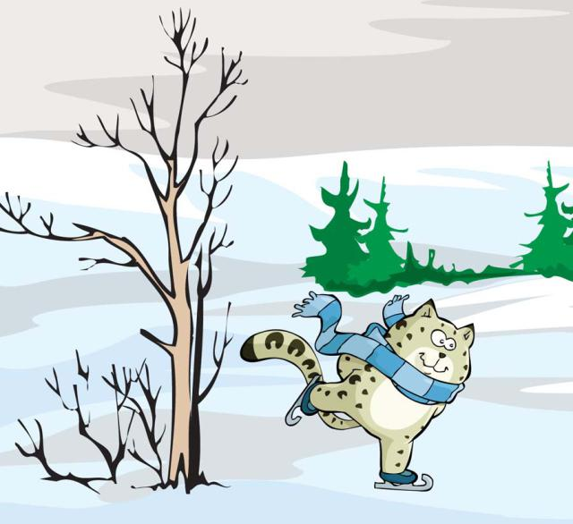](https://www.google.co.uk/url?sa=i&rct=j&q=&esrc=s&source=images&cd=&cad=rja&uact=8&ved=0ahUKEwj0uPHP9bHXAhVPqaQKHVcQCD4QjRwIBw&url=http://laoblogger.com/cat-snow-clipart.html&psig=AOvVaw3TncQsgi7Pqph2ObXL36xI&ust=1510331543486704)